**Soccer Robot**

**1. Description：**

Can you imagine that a robot can play soccer? This idea has became realistic. As we know, the RoboCup championship is generally held each year. In this part, we will create a soccer robot to play soccer.

1. **Preparation:**

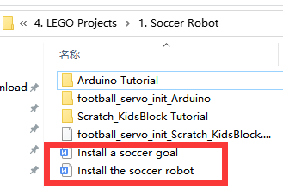

**3. Test Code**

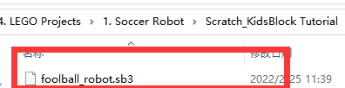

Build up the soccer goal with building blocks and place it at fixed location, connect the robot car through Wifi.

Put a small soccer in the middle of the claw of the robot car, press and hold down the button to enable the claw to hold the soccer, then press buttons 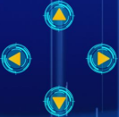to adjust the car’s movement direction so as to put the soccer close to the soccer goal. At last, release the button to allow the soccer to drop on the floor and roll to the soccer goal. If not, repeat the above step to shoot the goal.

If your friend owns this kind of soccer robot, you guys can hold a soccer match. It sounds amazing, right?.